Manea Robert-Petrisor
Group 934
Server OS and Service Setup Documentation
This document covers the installation and configuration of the server operating system and core services. Screenshots are inserted under each step to demonstrate the completed configuration and visual proof.

1. Install a Server Operating System
Environment Used:
- Virtualization Software: VirtualBox
- OS: Ubuntu Desktop 24.04 LTS
Steps Taken:
- Downloaded the ISO from ubuntu.com
- Created a new VirtualBox VM
- Allocated CPU, RAM, and storage
- Installed Ubuntu and created the user


2. SSH (Secure Shell)
Installation:
sudo apt install openssh-server
sudo systemctl enable ssh
sudo systemctl start ssh
Testing:
ssh vboxuser@localhost
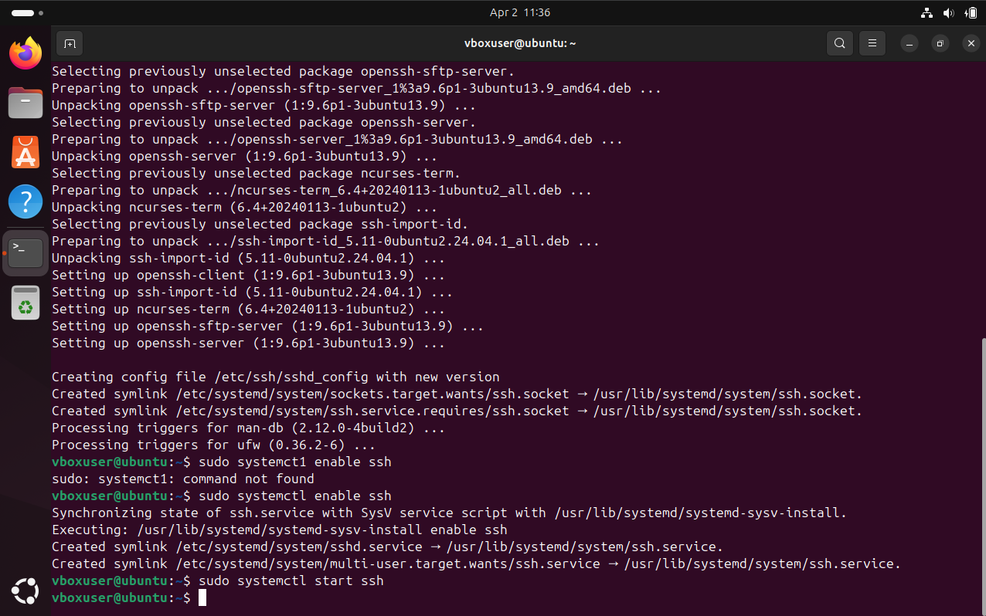
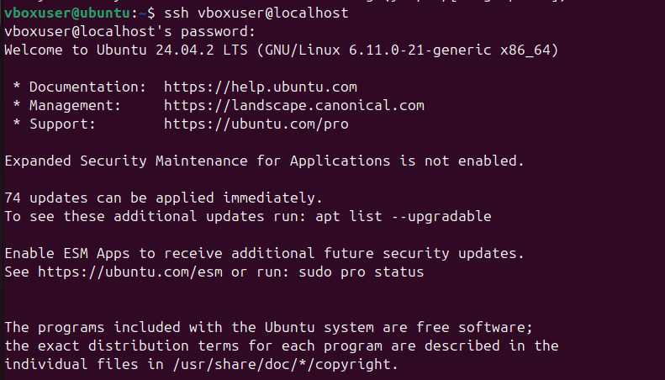

3. Web Server (Apache2)
Installation:
sudo apt install apache2
Testing: Visit http://localhost
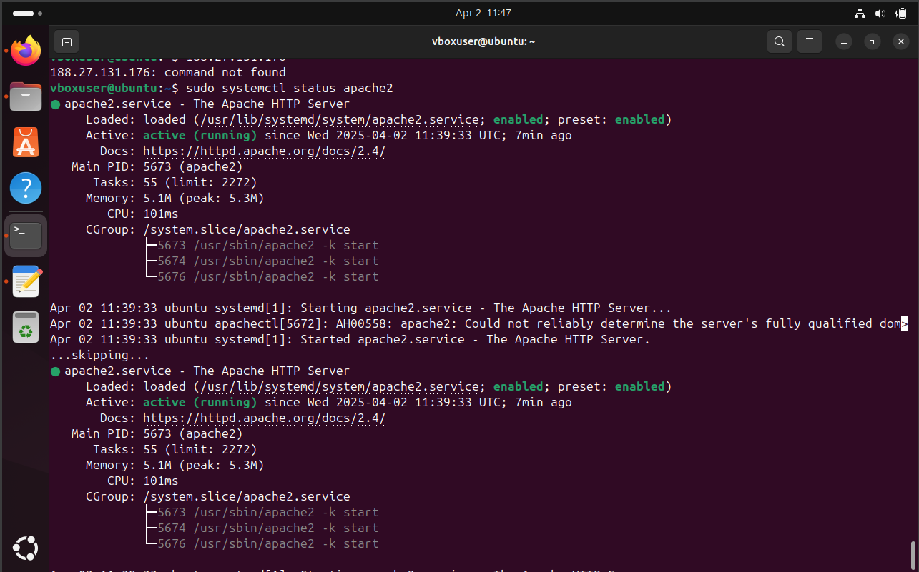
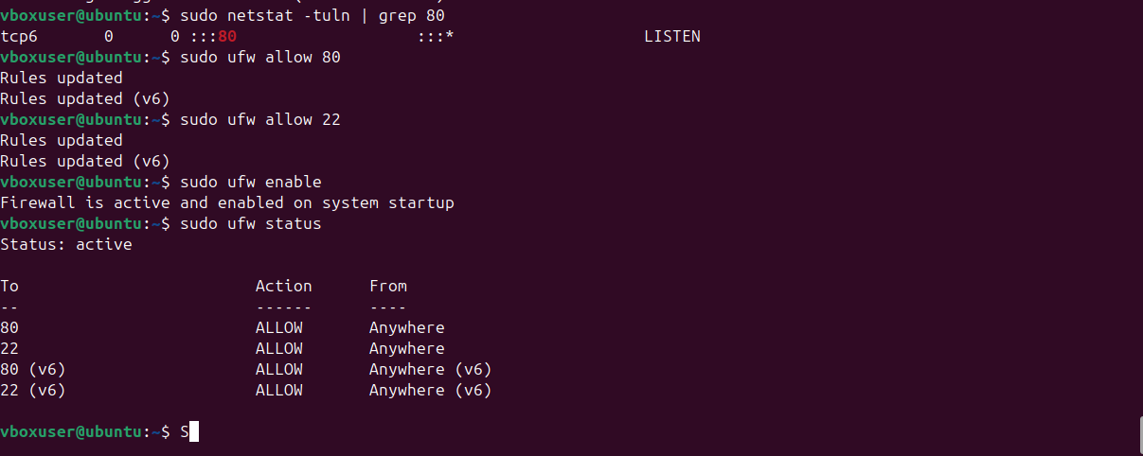
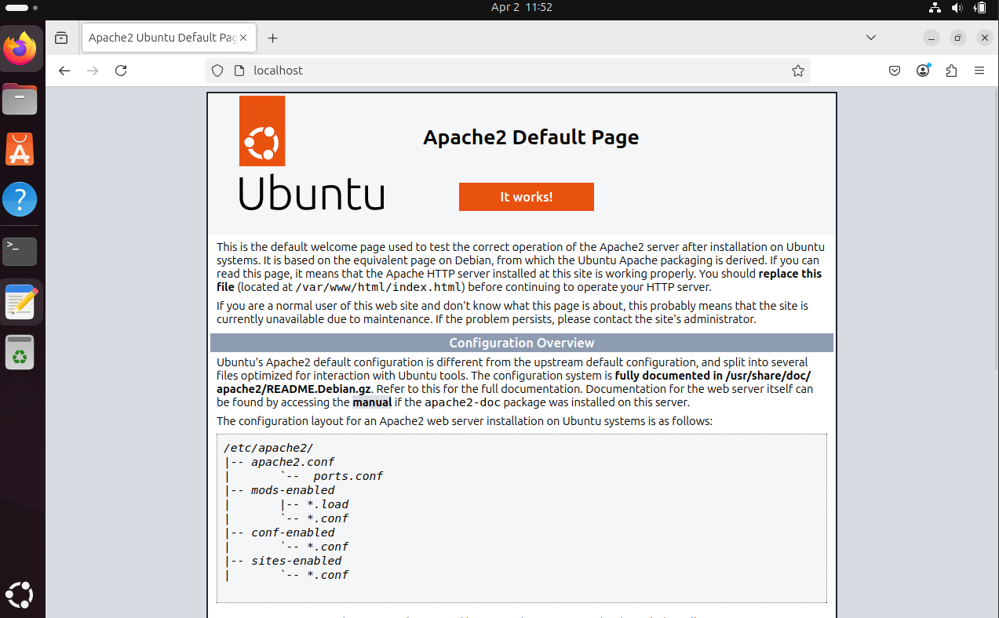

4. FTP Server (vsftpd)
Installation:
sudo apt install vsftpd
Enable and Configure:
sudo systemctl enable vsftpd
sudo systemctl start vsftpd
Tested using ftp Command
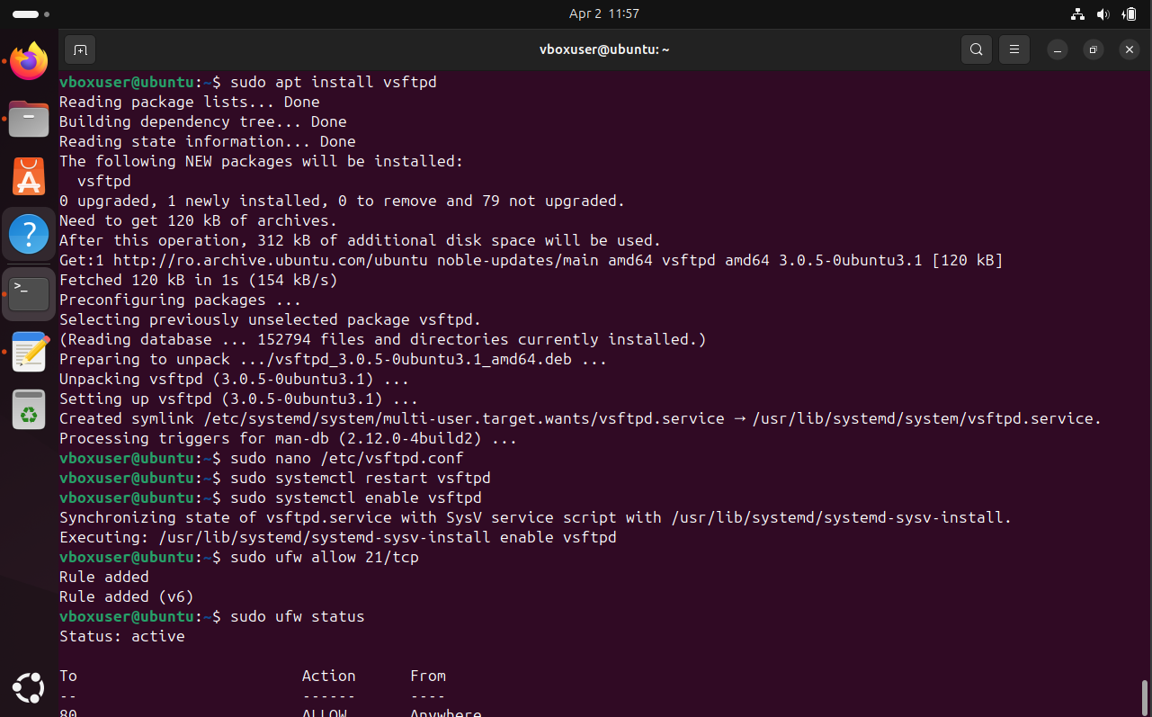
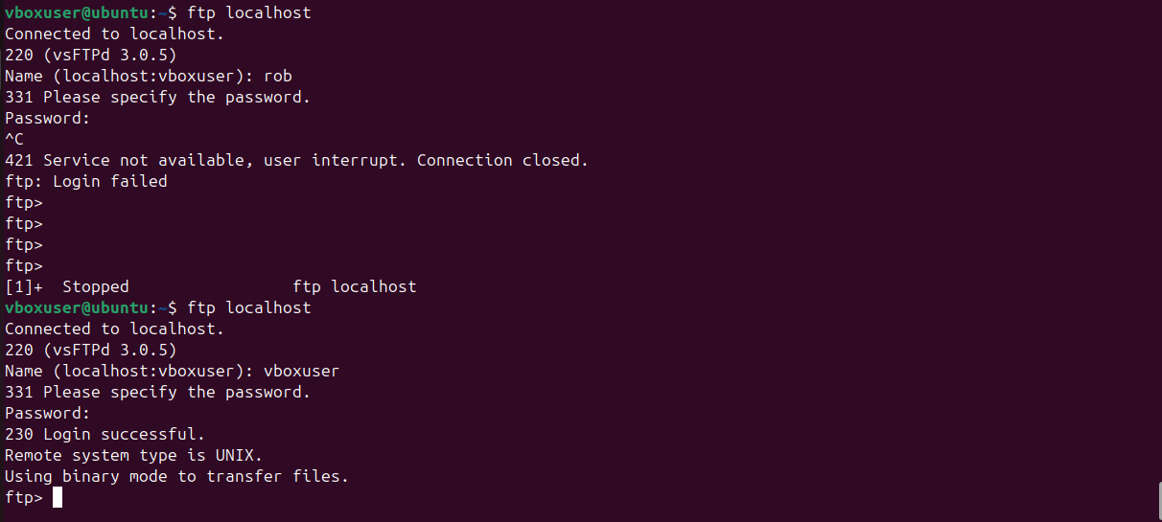

5. DHCP Server
Installation:
sudo apt install isc-dhcp-server
Configuration File:
sudo nano /etc/dhcp/dhcpd.conf
Modification made:
subnet 10.0.2.0 netmask 255.255.255.0 {
range 10.0.2.50 10.0.2.100;
option routers 10.0.2.1;
option domain-name-servers 8.8.8.8;
}
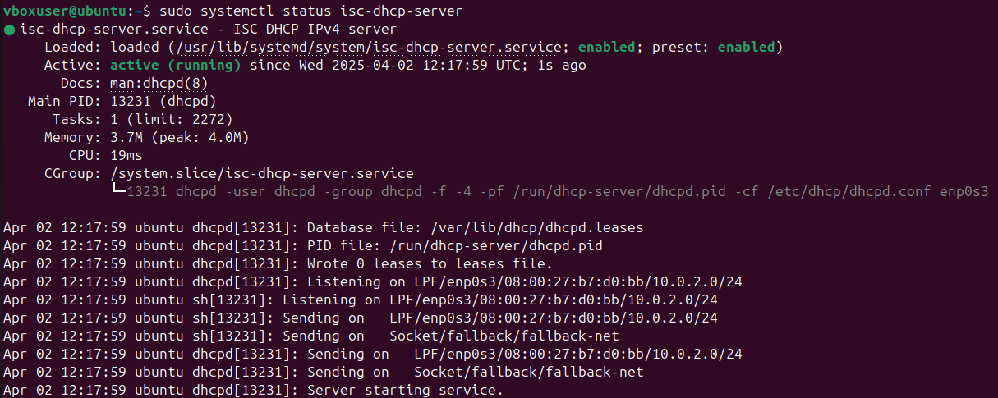
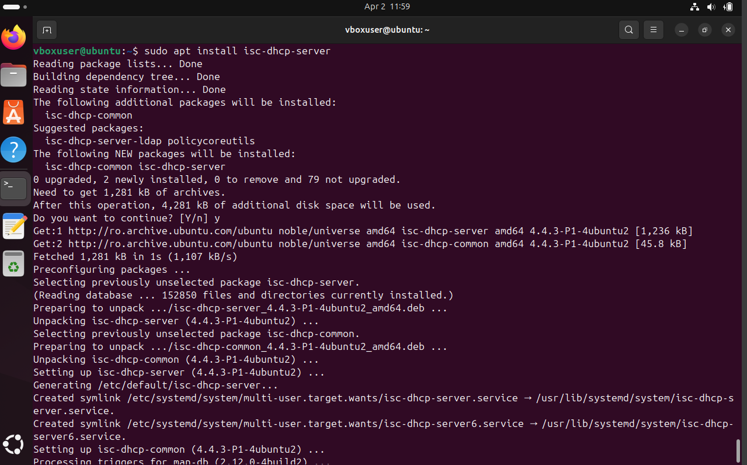

6. DNS Server (BIND9)
Installation:
sudo apt install bind9
Testing:
nslookup google.com
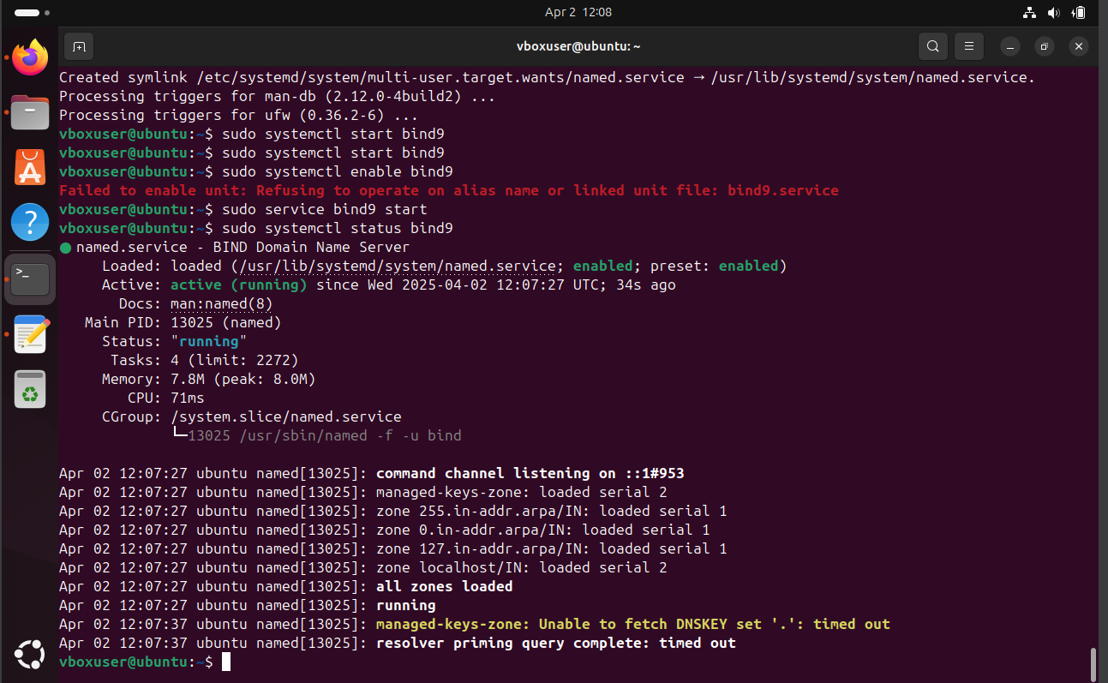
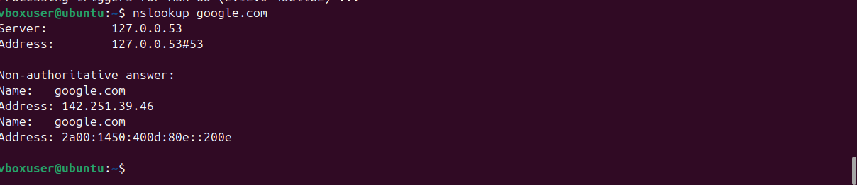

7. Mail Server (Postfix)
Installation:
sudo apt install postfix
Choosed: "Internet Site" during setup
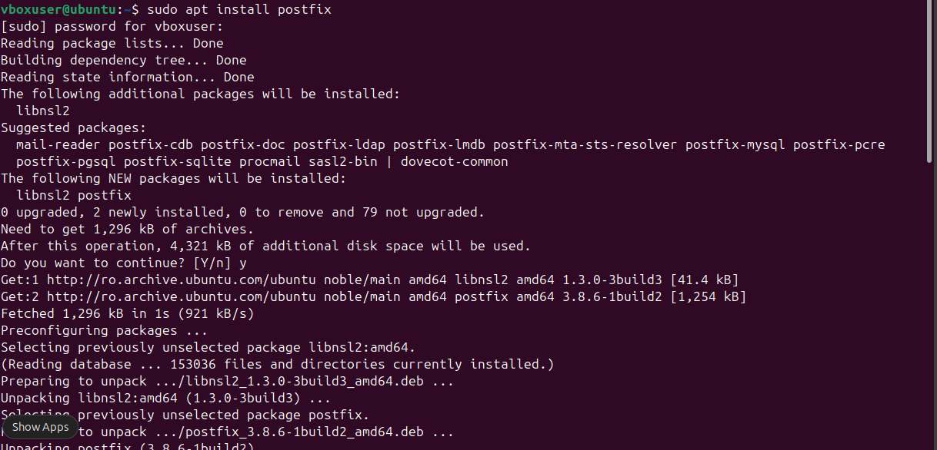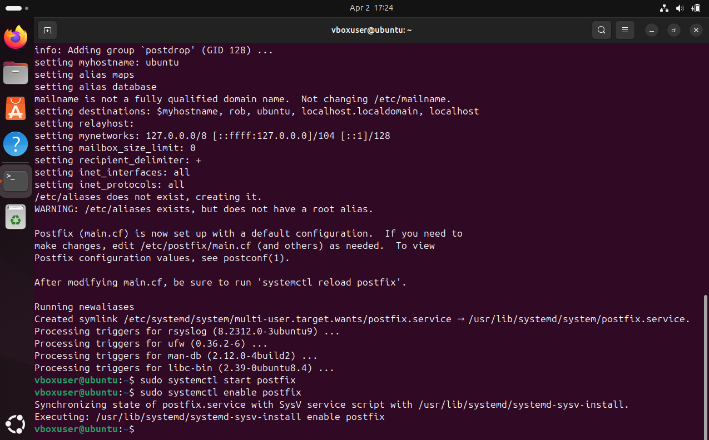
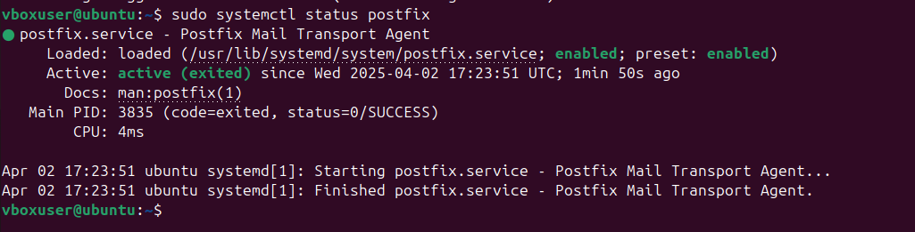

8. POP3/IMAP (Dovecot)
Installation:
sudo apt install dovecot-core dovecot-imapd dovecot-pop3d
Testing:
openssl s_client -connect localhost:993
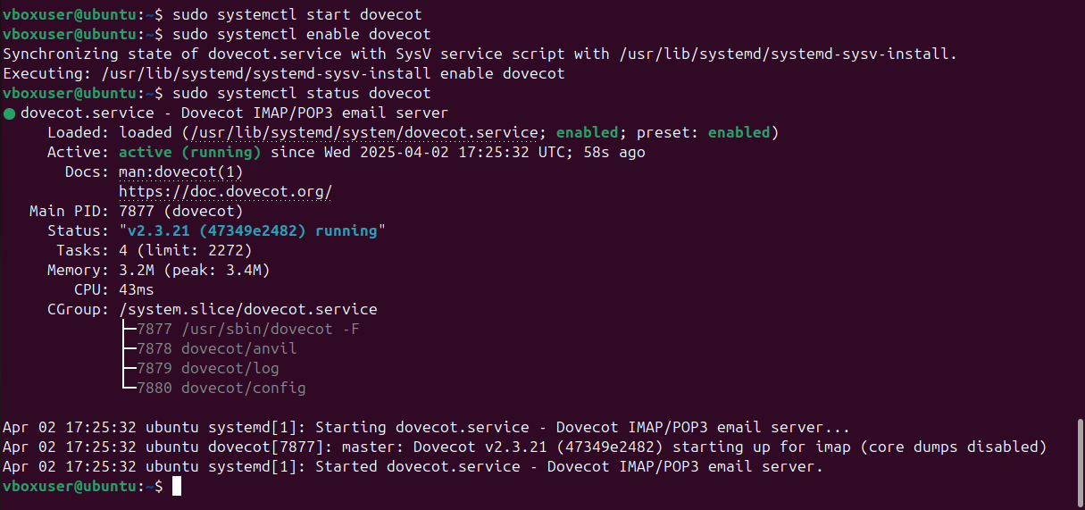
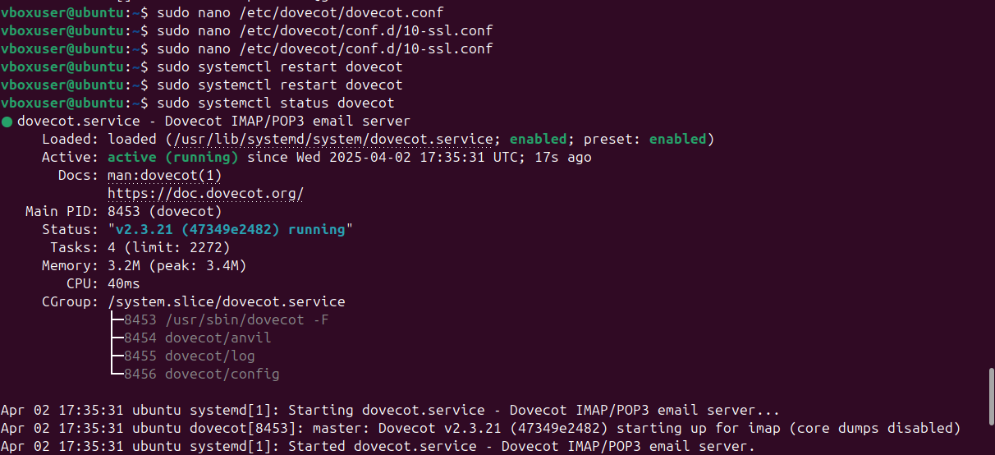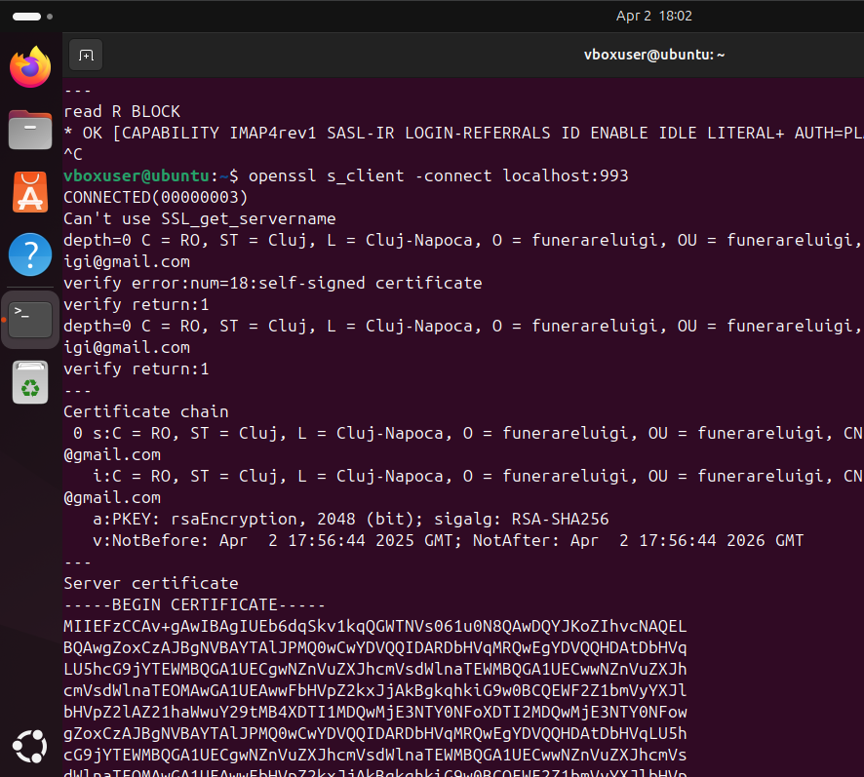
9. Proxy (Squid)
Installation:
sudo apt install squid
Testing:
curl -x http://localhost:3128 http://example.com
Configure browser to use: http://localhost:3128
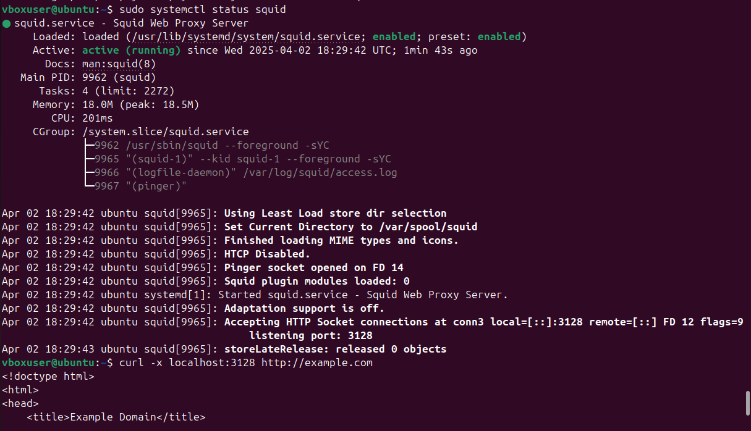

10. Docker
Installation:
sudo apt install docker.io
sudo systemctl start docker
sudo systemctl enable docker
Test Docker:
sudo docker run hello-world
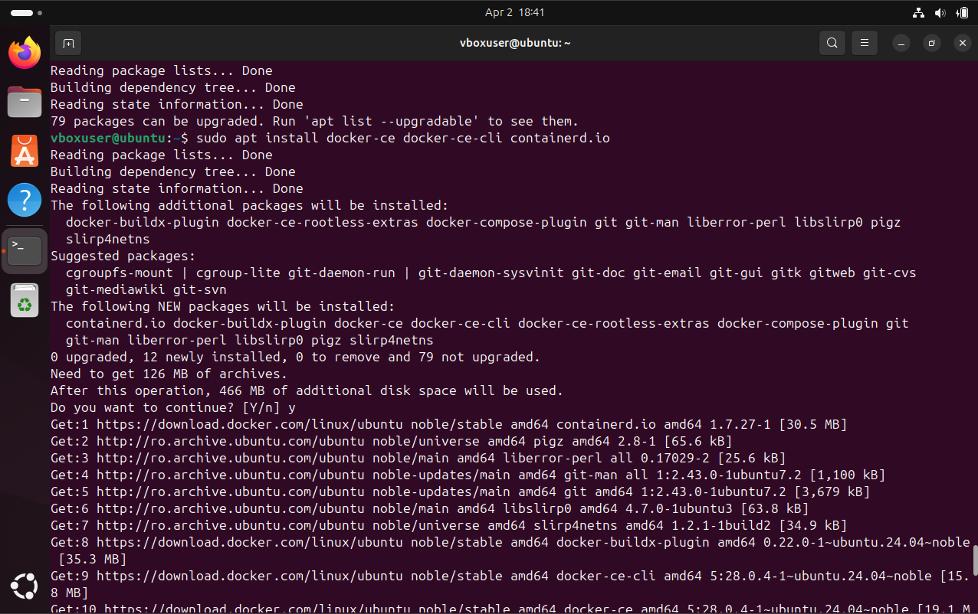
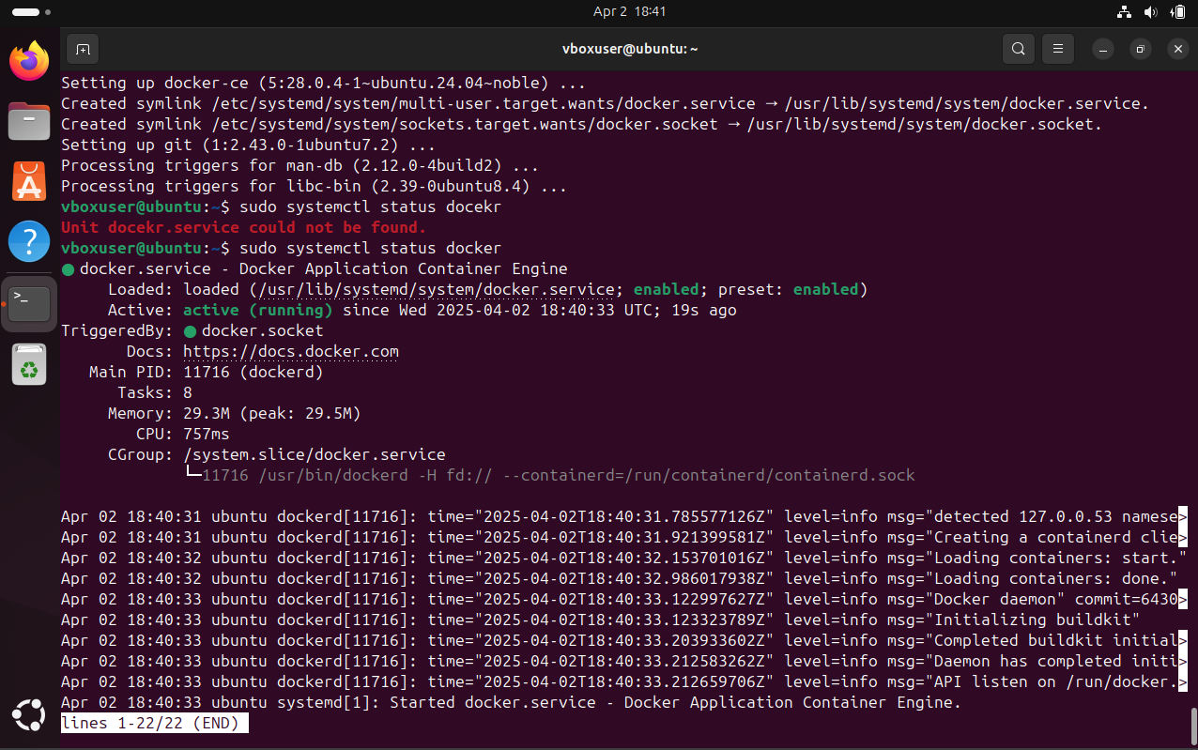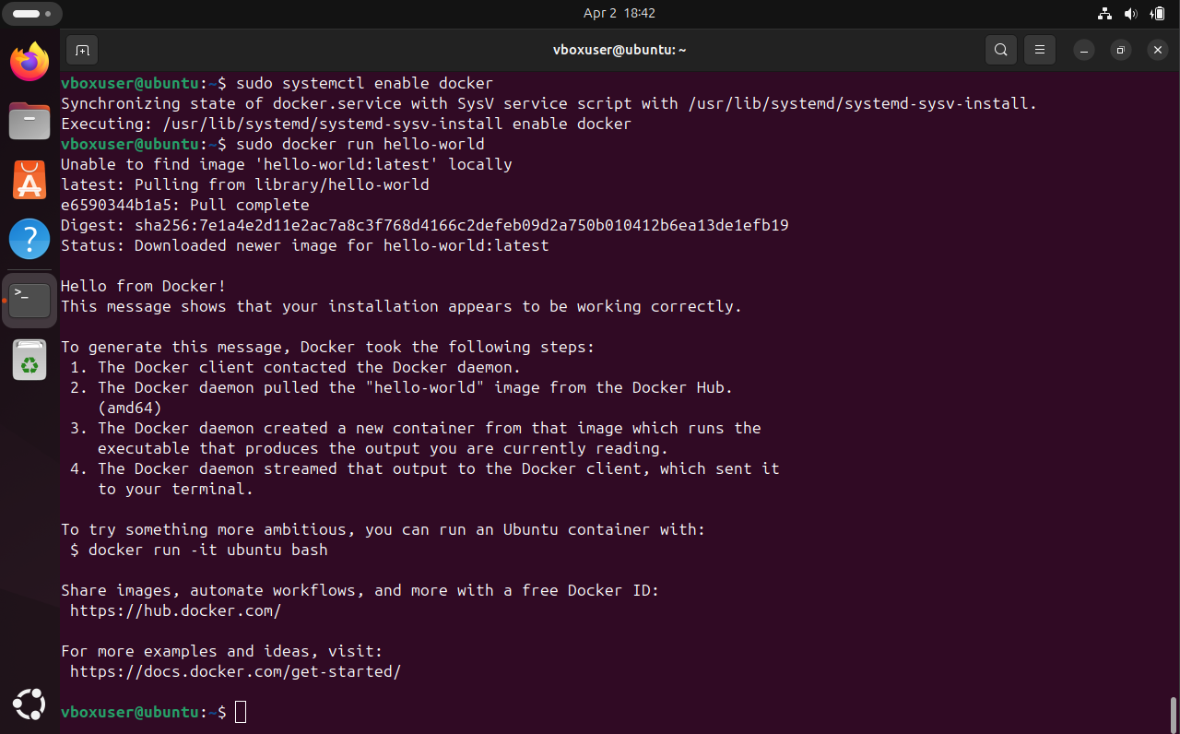

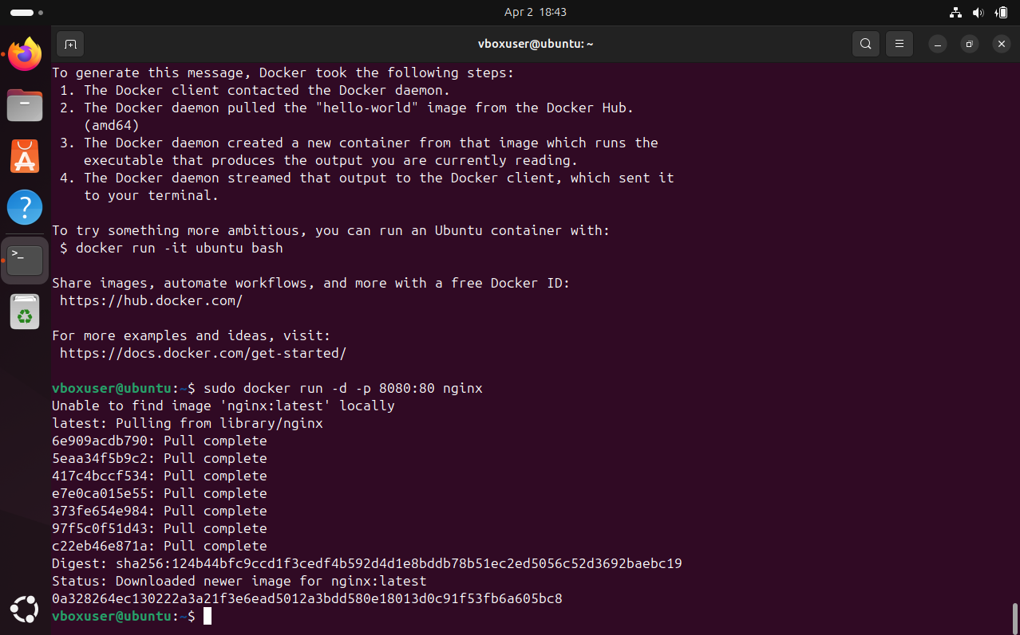

System Administration & Security Tasks Documentation
This document summarizes all administration and security tasks performed on the Ubuntu server, including commands used and brief descriptions. Screenshots will be inserted after each step to provide visual proof.

1. Monitor Services Availability (Up/Down)
Tool: systemctl, monit
Commands Used:
sudo systemctl status apache2
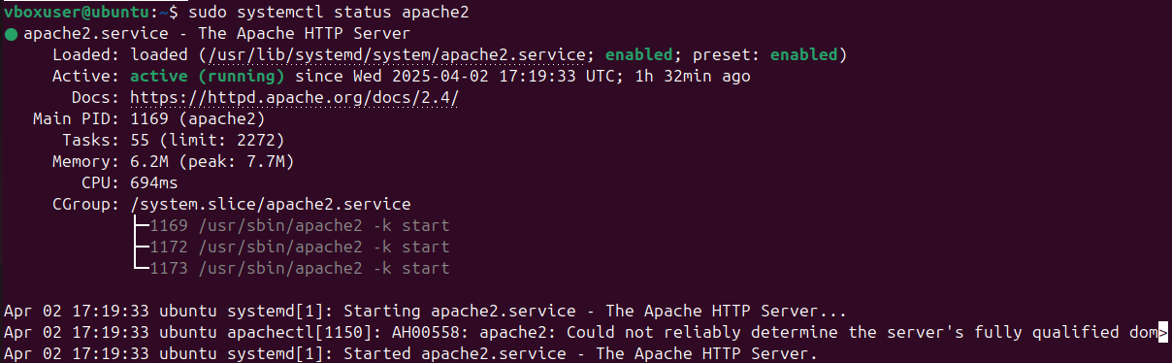
sudo systemctl status ssh
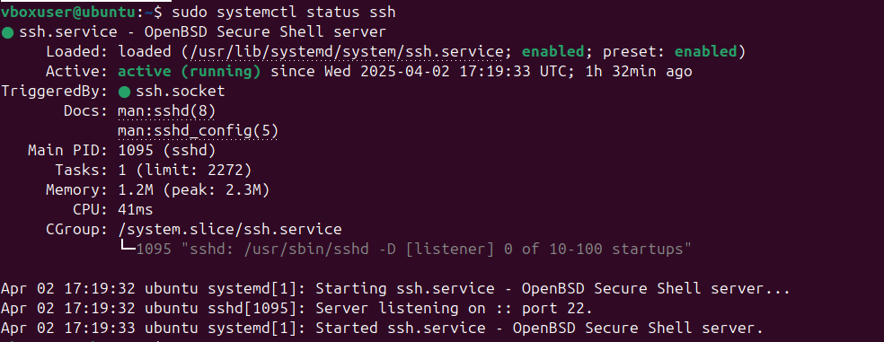
sudo systemctl status dovecot
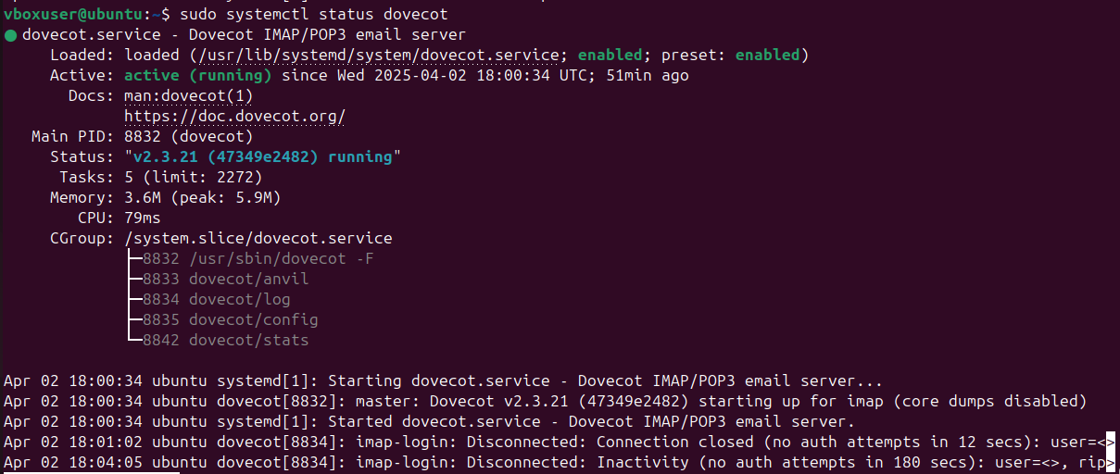
Description: Checks whether each service is currently active and running.
Optional: Install and configure monit
sudo apt install monit
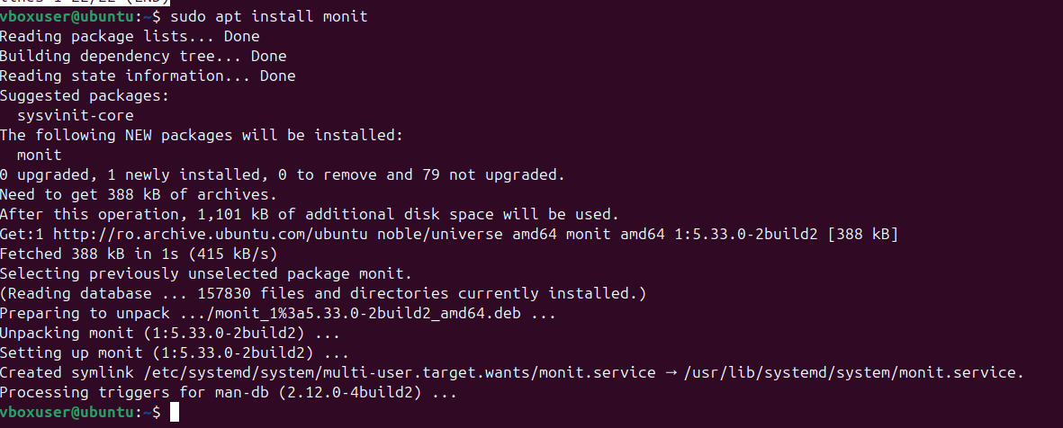
sudo nano /etc/monit/monitrc
Enable web interface:
set httpd port 2812 and
allow localhost
Example service monitoring configuration:
check process sshd with pidfile /run/sshd.pid
start program = "/etc/init.d/ssh start"
stop program = "/etc/init.d/ssh stop"
Restart monit:
sudo systemctl restart monit
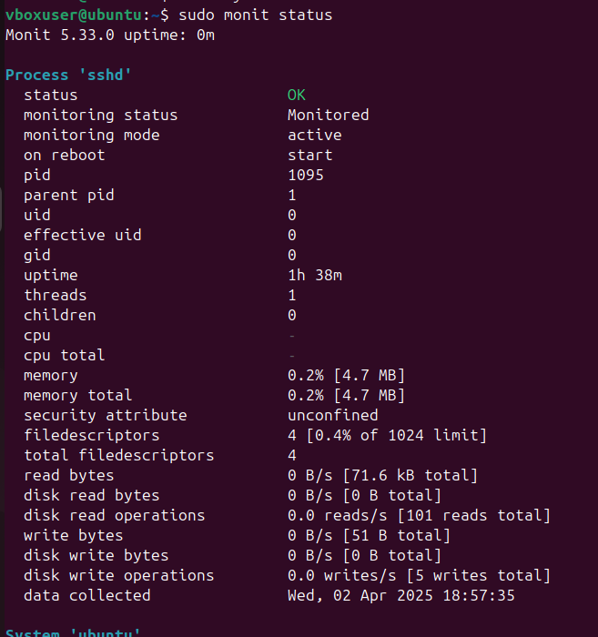

Web interface:
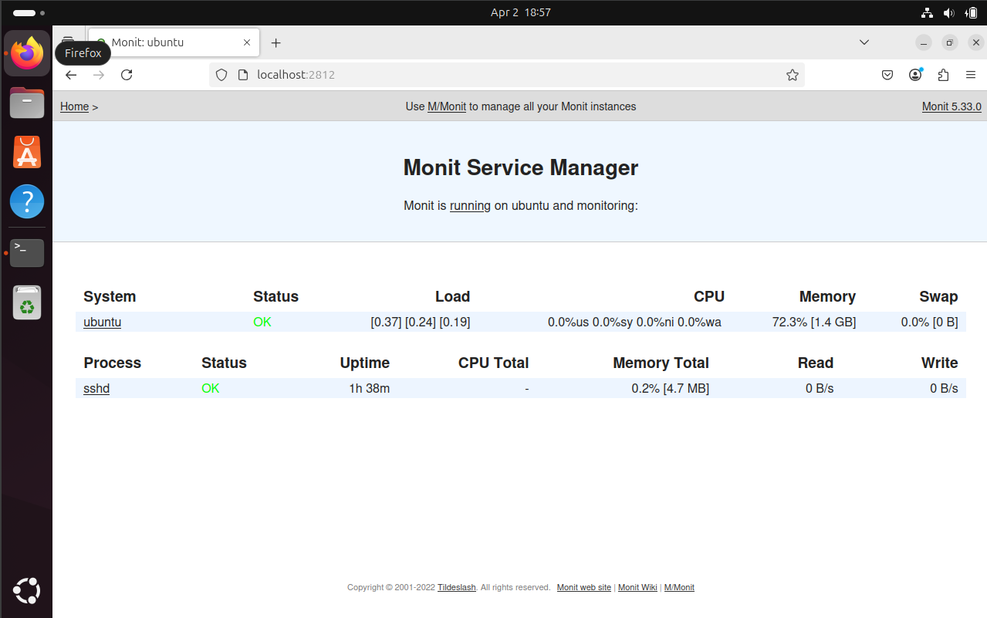

2. Performance Testing
Tools: htop, sar, stress
Commands Used:
sudo apt install htop sysstat stress
htop
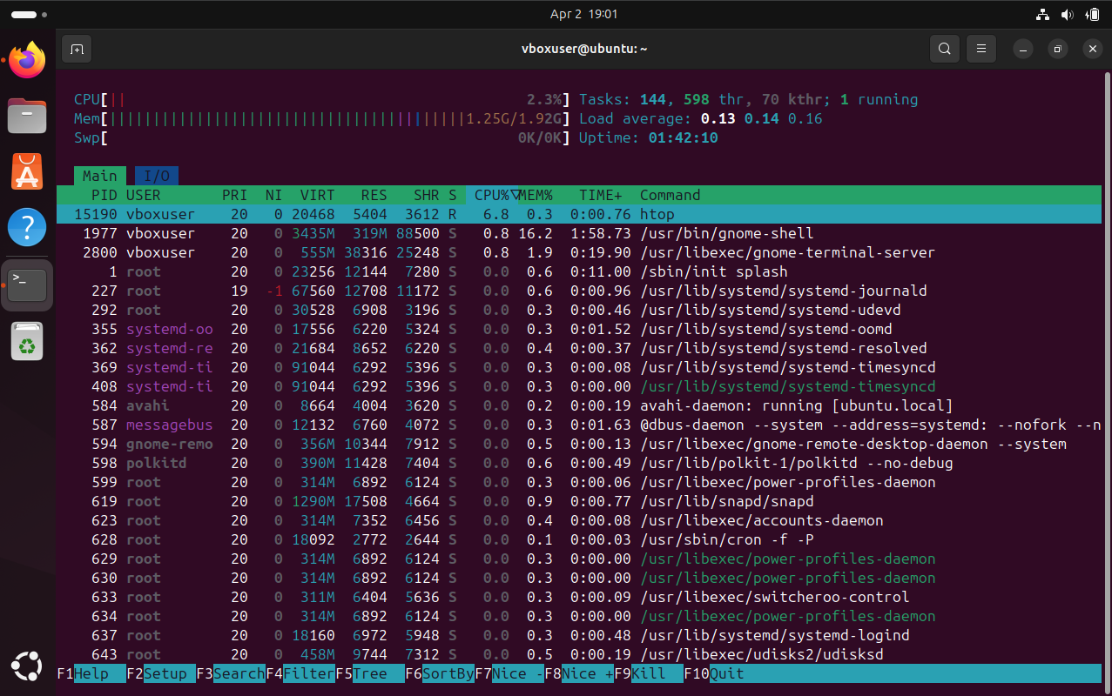

sar -u 1 5
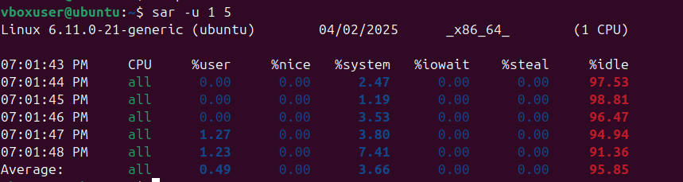
stress --cpu 2 --timeout 30
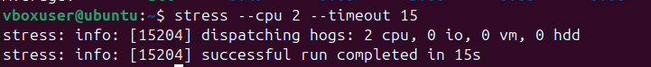
Description:
- htop: Interactive resource monitor
- sar: Collects CPU usage samples
- stress: Simulates CPU load

3. Log Analyzer
Tools: logwatch, journalctl, less
Commands Used:
sudo apt install logwatch
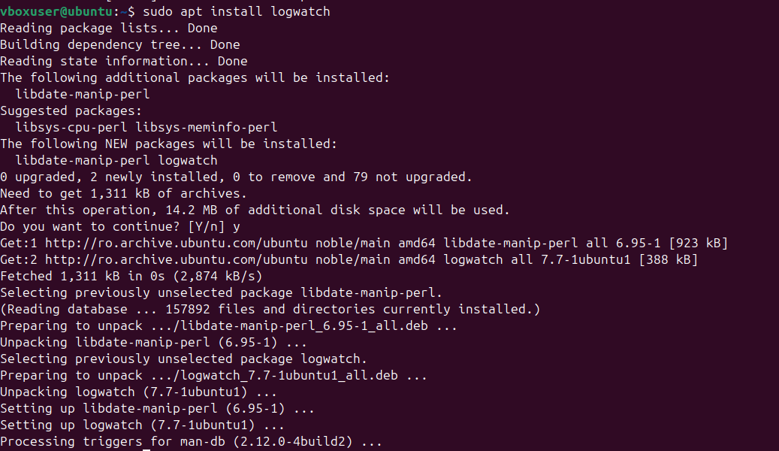

sudo logwatch --detail high --mailto example@email.com --service all --range today
sudo journalctl -xe
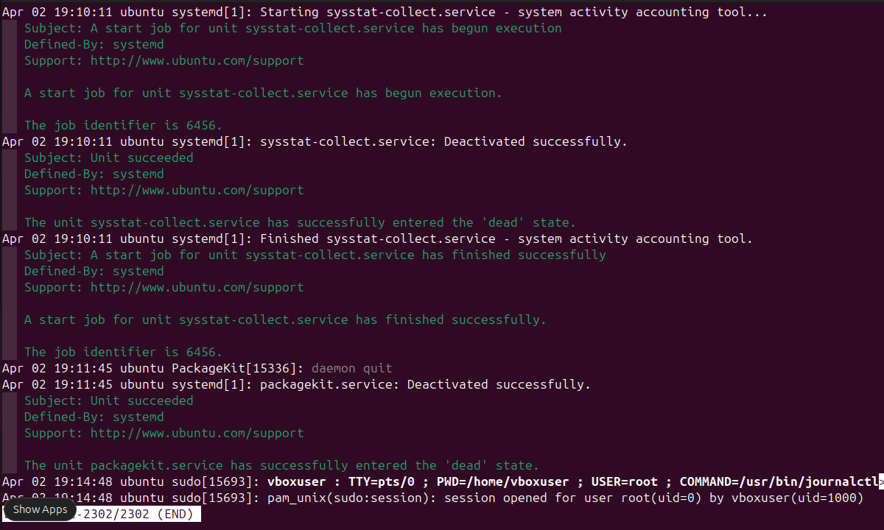

sudo less /var/log/mail.log
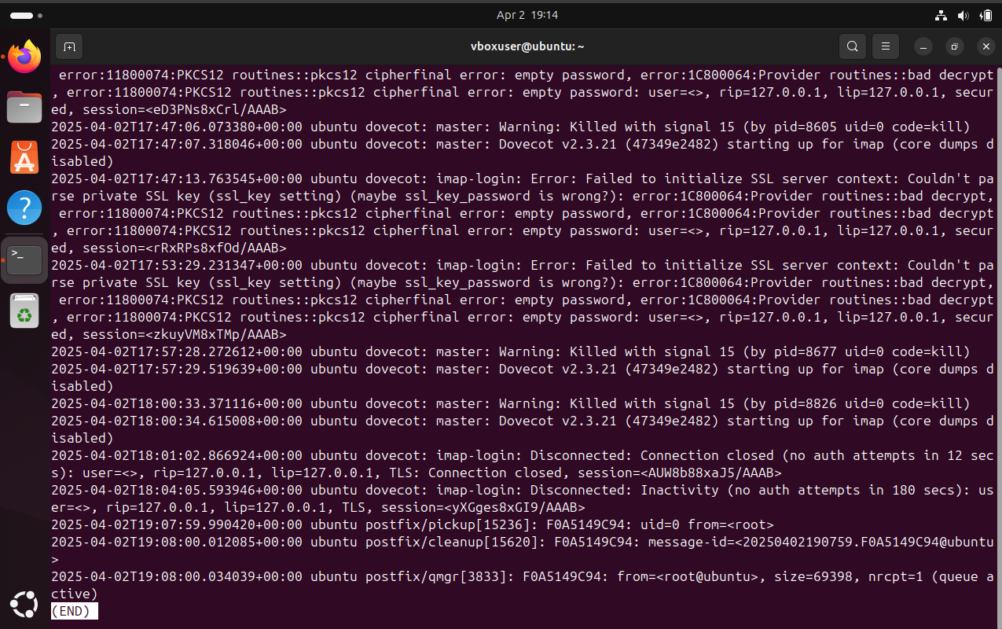
Description:
- Analyze system logs
- Useful for diagnosing issues

4. Backup Tasks
Tools: rsync, tar, cron
Commands Used:
sudo rsync -av /etc /home/user/backups/etc-backup
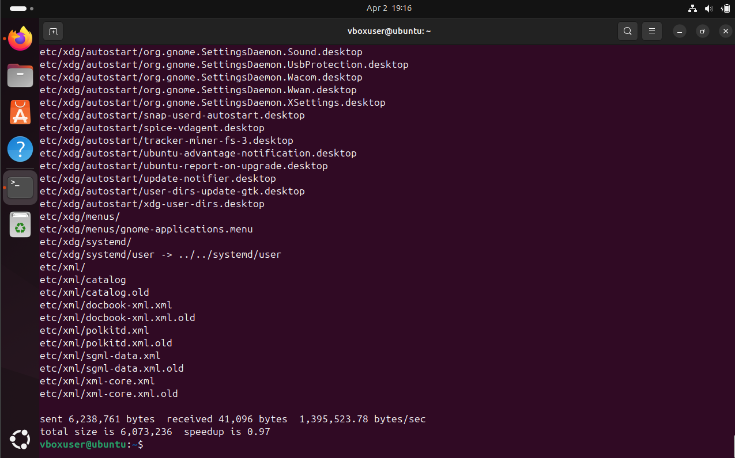

sudo tar -czvf etc-backup.tar.gz /etc
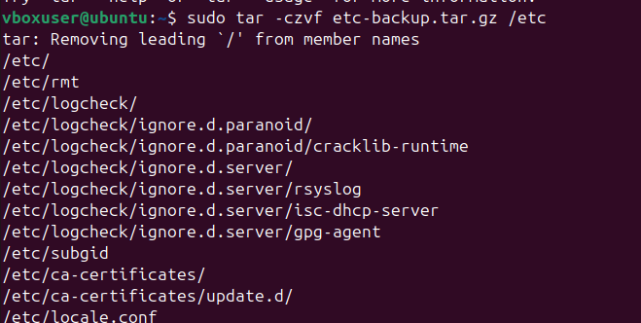
crontab -e
Crontab Entry Example:
0 2 * * * tar -czf /home/user/backups/etc-$(date +\%F).tar.gz /etc
Description: Scheduled backup of /etc using tar. Can be automated with cron.

5. Firewall Configuration
Tool: ufw
Commands Used:
sudo apt install ufw
sudo ufw enable
sudo ufw allow ssh
sudo ufw allow 80/tcp
sudo ufw allow 443/tcp
sudo ufw status
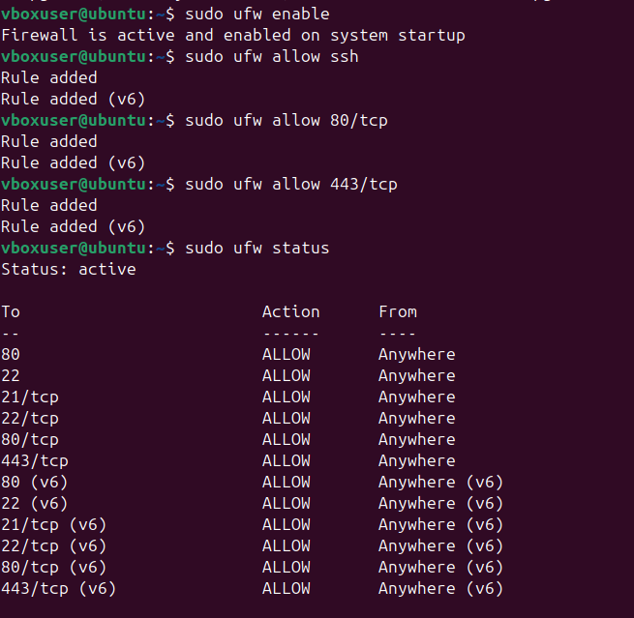
Description: Enables and configures a basic firewall to allow essential services.

6. Brute Force Detection / Prevention
Tool: fail2ban
Commands Used:
sudo apt install fail2ban
sudo systemctl start fail2ban
sudo systemctl enable fail2ban
sudo fail2ban-client status
sudo fail2ban-client status sshd
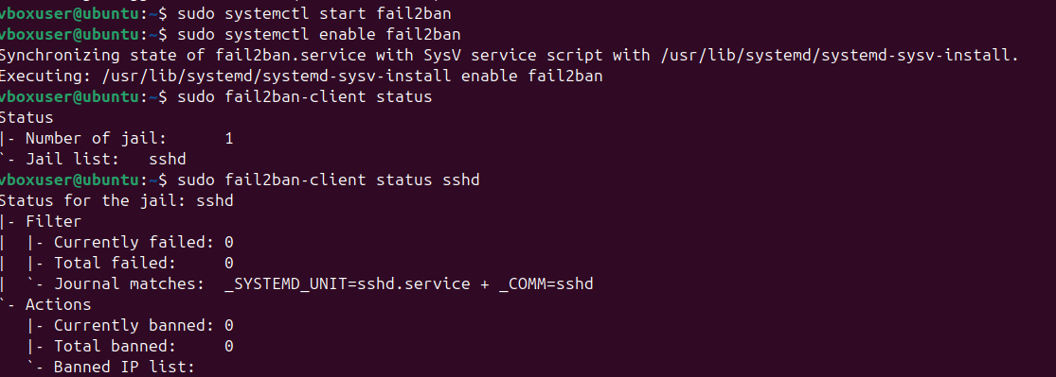
Log File:
sudo less /var/log/fail2ban.log
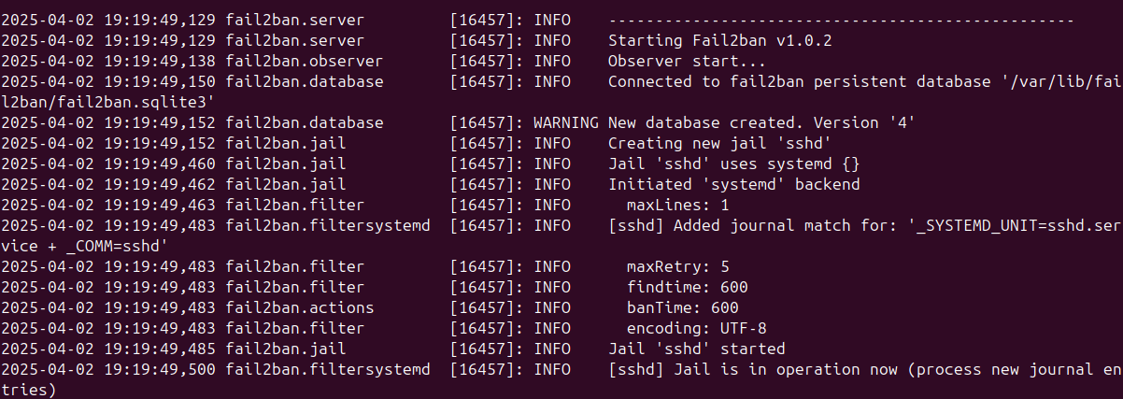

Description: Automatically bans IPs after failed login attempts to prevent brute force attacks.
One such test:
